__大灣__國中__110___年__1__學期___2__次月考第__6__份(理化)
一.選擇題
1. | 2. | 3. | 4. | 5.
C | B | B | A | D
9S大灣110010201 | 9S大灣110010202 | 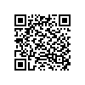9S大灣110010203 | 9S大灣110010204 | 9S大灣110010205
6. | 7. | 8. | 9. | 10.
A | C | D | A | C
9S大灣110010206 | 9S大灣110010207 | 9S大灣110010208 | 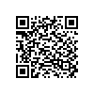9S大灣110010209 | 9S大灣110010210
11. | 12. | 13. | 14. | 15.
B | D | A | D | B
9S大灣110010211 | 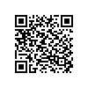9S大灣110010212 | 9S大灣110010213 | 9S大灣110010214 | 9S大灣110010215
16. | 17. | 18. | 19. | 20.
B | B | D | D | D
9S大灣110010216 | 9S大灣110010217 | 9S大灣110010218 | 9S大灣110010219 | 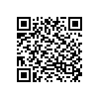9S大灣110010220
21. | 22. | 23. | 24. | 25.
C | C | A | D | C
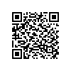9S大灣110010221 | 9S大灣110010222 | 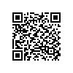9S大灣110010223 | 9S大灣110010224 | 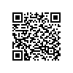9S大灣110010225
26. | 27. | 28. | 29. | 30.
C | D | B | D | C
9S大灣110010226 | 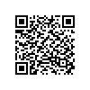9S大灣110010227 | 9S大灣110010228 | 9S大灣110010229 | 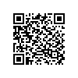9S大灣110010230
31. | 32. | 33. | 34. | 35.
A | C | C | D | B
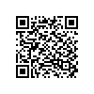9S大灣110010231 | 9S大灣110010232 | 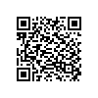9S大灣110010233 | 9S大灣110010234 | 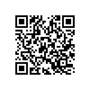9S大灣110010235
二.題組題
36. | 37. | 38. | 39. | 40.
C | D | A | B | C
9S大灣110010236 | 同上 | 同上 | 9S大灣110010237 | 同上
41. | 42. | 43. | 44. | 45.
D | D | C | B | B
同上 | 同上 | 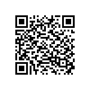9S大灣110010238 | 同上 | 同上

