__溪湖__國中__110___年__1__學期___2__次月考第__2__份(理化)
一.選擇題
1. | 2. | 3. | 4. | 5.
D | A | C | B | B
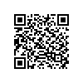9S溪湖110010201 | 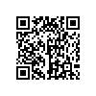9S溪湖110010202 | 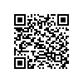9S溪湖110010203 | 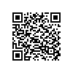9S溪湖110010204 | 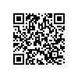9S溪湖110010205
6. | 7. | 8. | 9. | 10.
D | D | C | C | C
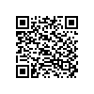9S溪湖110010206 | 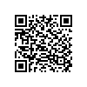9S溪湖110010207 | 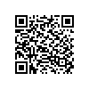9S溪湖110010208 | 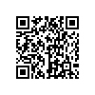9S溪湖110010209 | 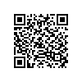9S溪湖110010210
11. | 12. | 13. | 14. | 15.
B | A | D | D | A
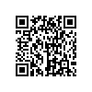9S溪湖110010211 | 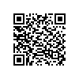9S溪湖110010212 | 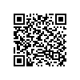9S溪湖110010213 | 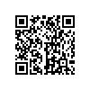9S溪湖110010214 | 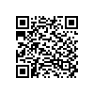9S溪湖110010215
16. | 17. | 18. | 19. | 20.
B | A | B | D | C
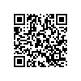9S溪湖110010216 | 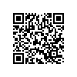9S溪湖110010217 | 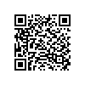9S溪湖110010218 | 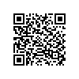9S溪湖110010219 | 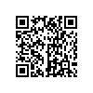9S溪湖110010220
21. | 22. | 23. | 24. | 25.
B | C | A | D | A
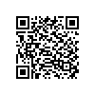9S溪湖110010221 | 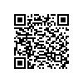9S溪湖110010222 | 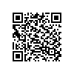9S溪湖110010223 | 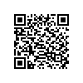9S溪湖110010224 | 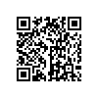9S溪湖110010225
26. | 27.
A | B
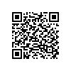9S溪湖110010226 | 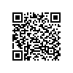9S溪湖110010227
二.題組
1.(1) | 1.(2) | 1.(3) | 2. | 3.(1)
B | C | A | AF | C
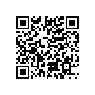9S溪湖110010228 | 同上 | 同上 | 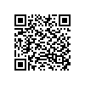9S溪湖110010229 | 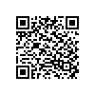9S溪湖110010230
3.(2) | 4 | 5 | 6.(1) | 6.(2)
B | ABC | 乙丁戊己庚 | CE | 5
同上 | 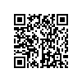9S溪湖110010231 | 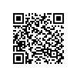9S溪湖110010232 | 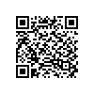9S溪湖110010233 | 同上
7 | 8 | 9
D | BD | A
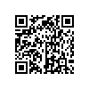9S溪湖110010234 | 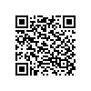9S溪湖110010235 | 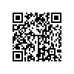9S溪湖11010136

