__大樹__國中__110___年__1__學期___1__次月考第__3__份(理化)
一.選擇題
1. | 2. | 3. | 4. | 5.
C | B | C | B | B
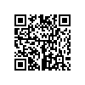 9S大樹110010101 | 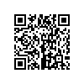 9S大樹110010102 | 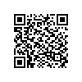 9S大樹110010103 | 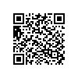 9S大樹110010104 | 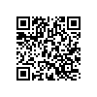 9S大樹110010105
6. | 7. | 8. | 9. | 10.
B | C | D | A | D
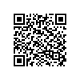 9S大樹110010106 | 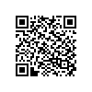 9S大樹110010107 | 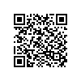 9S大樹110010108 | 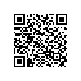 9S大樹110010109 | 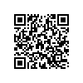 9S大樹110010110
11. | 12. | 13. | 14. | 15.
B | C | B | B | A
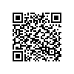 9S大樹110010111 | 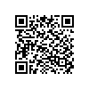 9S大樹110010112 | 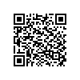 9S大樹110010113 | 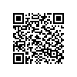 9S大樹110010114 | 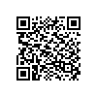 9S大樹110010115
16. | 17. | 18. | 19. | 20.
B | D | D | B | C
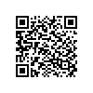 9S大樹110010116 | 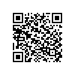 9S大樹110010117 | 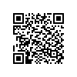 9S大樹110010118 | 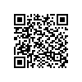 9S大樹110010119 | 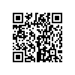 9S大樹110010120
21. | 22. | 23. | 24. | 25.
A | B | D | B | A
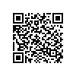 9S大樹110010121 | 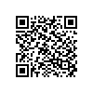 9S大樹110010122 | 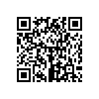 9S大樹110010123 | 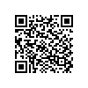 9S大樹110010124 | 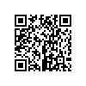 9S大樹110010125
26. | 27. | 28. | 29. | 30.
A | A | D | B | D
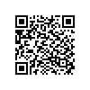 9S大樹110010126 | 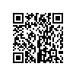 9S大樹110010127 | 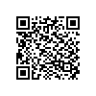 9S大樹110010128 | 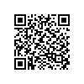 9S大樹110010129 | 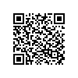 9S大樹110010130
31. | 32. | 33. | 34. | 35.
D | A | A | C | A
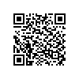 9S大樹110010131 | 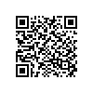 9S大樹110010132 | 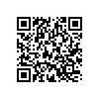 9S大樹110010133 | 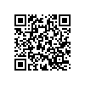 9S大樹110010134 | 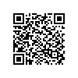 9S大樹110010135
36. | 37. | 38. | 39. | 40.
C | C | C | B | A
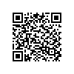 9S大樹110010136 | 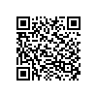 9S大樹110010137 | 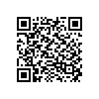 9S大樹110010138 | 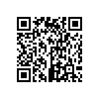 9S大樹110010139 | 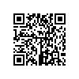 9S大樹11010140
二.題組
1. | 2. | 3. | 4. | 5.
C | B | C | B | A
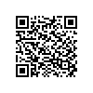 9S大樹110010141 | 同上 | 同上 | 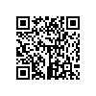 9S大樹110010142 | 同上
6. | 7. | 8. | 9. | 10.
1.8 | 3.0 | 2.4 | 1.0 | 0
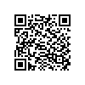 9S大樹110010143 | 同上 | 同上 | 同上 | 同上

