____林園___國中____110____年___1___學期____1___次月考第___1__份
一.選擇題
1. | 2. | 3. |  | 4. | 5.
C | C | A |  | D | B
8M林園110010101 | 8M林園110010102 | 8M林園110010103 |  | 8M林園110010104 | 8M林園110010105
6. | 7. | 8.
B | A | D
8M林園110010106 | 8M林園110010107 | 8M林園110010108
二.填充題
1. | 2. | 3. |  | 4. | 5.
5 | -10x³ | -9x+6x² |  | 3 | 11
8M林園110010109 | 8M林園110010110 | 8M林園110010111 |  | 8M林園110010112 | 8M林園110010113
6. | 7. | 8. |  | 9. | 10.
-400 | 3950 | 6x³+6x²-3x+9 |  | 6 | 14
8M林園110010114 | 8M林園110010115 | 8M林園110010116 |  | 8M林園110010117 | 8M林園110010118
11. | 12. | 13. |  | 14. | 15.
$\frac{20}{3}$x-5 | 683 | 6691$\frac{6}{25}$ |  | 14x+21 | 44
8M林園110010119 | 8M林園110010120 | 8M林園110010121 |  | 8M林園110010122 | 8M林園110010123
16.
1125
8M林園110010124
三.計算題
1.(1) |  |  | 1.(2)
16或25 |  |  | 14500
8M林園110010125 |  |  | 同上
2.
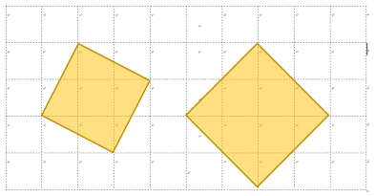
8M林園110010126

